**Payroll Systems**

**TRS DTA QR: Submitting Timesheet on Behalf of Employee**

A supervisor can submit a timesheet on behalf of an employee in situations where the employee is unable to submit their own timesheet. The supervisor has to be the primary, backup or optional supervisor for the employee’s assignment in TRS. A supervisor should not regularly submit a timesheet on behalf of an employee, but the ability exist for urgent situations.

The timesheet must have one of the following statuses:

* NONE (never created by the employee)
* SAVED (by the employee)
* RETURNED_BY_SUPERVISOR
* RECALLED_BY_EMPLOYEE

Use the **Approve as Primary**, **Approve as Backup**, or **Manage Timesheets** tab to submit a timesheet on behalf of an employee.

**To Submit a Timesheet on behalf of an employee:**

The steps below are for submitting a timesheet on behalf of an employee, using the **Manage Timesheets** menu.

1. Under the **Manage My Staff** tab, select **Manage Timesheets.**

* **Search Timesheet** is the default screen displayed.

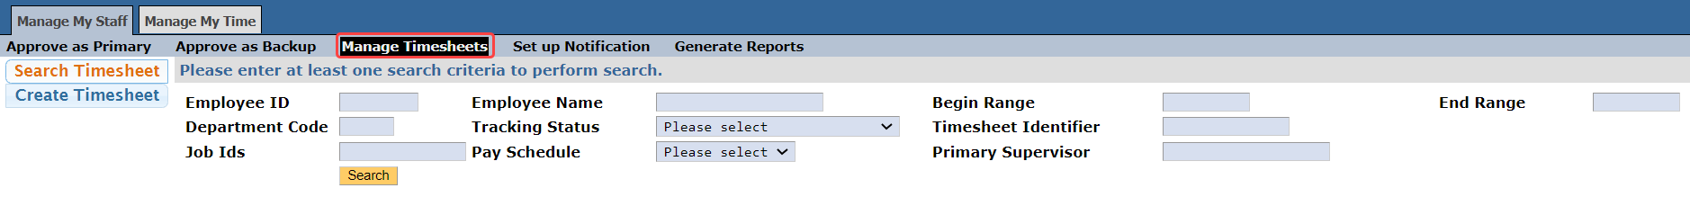

1. Enter the employee and timesheet information to search for the applicable timesheet.
2. Click on **Search**. Timesheets that meet the search criteria entered will be displayed.

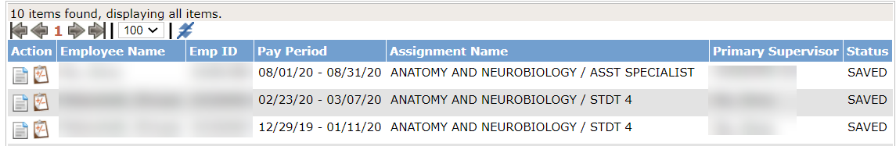

1. Click on the **View Timesheet** icon, next to the employee and pay period to submit a timesheet for. The timesheet calendar will be displayed.

Sample Biweekly Timesheet to be submitted

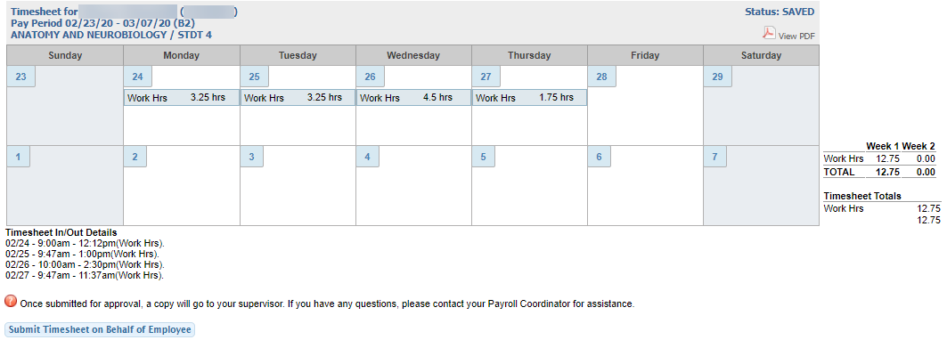

Sample Monthly Timesheet to be submitted

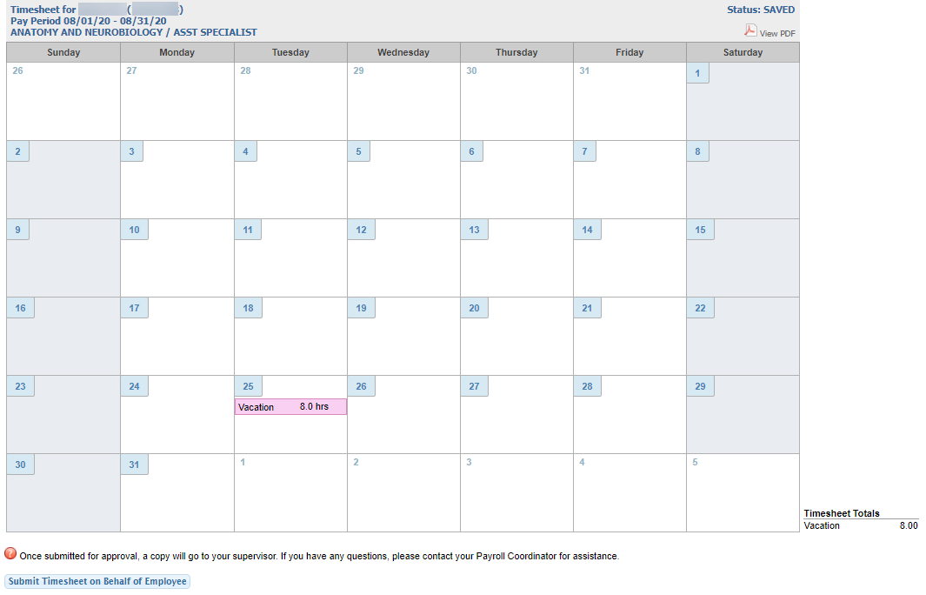

Sample Monthly Timesheet with Exception Hours Reported to be submitted

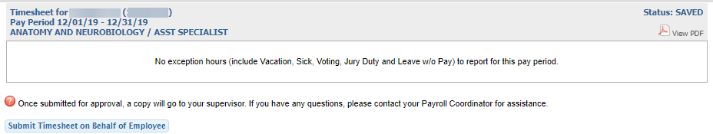

1. Click on **Submit Timesheet on Behalf of Employee**