**Payroll Systems**

**TRS DTA QR: Leave without Pay (LWOP)**

TRS utilizes the UC time and attendance business rules to capture all hour types including work hours, vacation, sick, comp time used, leave without pay (LWOP), voting, and jury duty.

All approved leaves of absence without pay and leaves of absence with pay due to Family and Medical Leave Act (FMLA) requirements must be entered in TRS.

**TYPES OF LEAVE:**

* Cat (Catastrophic Leave)
* LWOP - use this entry to record Leave Without Pay time off
* FMLA Cat (Catastrophic Leave)
* FMLA Vac - use to report FMLA vacation time (with pay)
* FMLA Sck (Sick) - use to report FMLA sick leave (with pay)
* FMLA NP (no pay) - use to report FMLA time without pay
* FMLA PTO (FMLA Med Center PTO)
* FMLA Cmp (comp) - Comp Time (used) for FMLA leave (used hours from employees comp blank in UCPath)
* Emerg EE - Emergency Paid Sick Leave – EE
* Emerg FM - Emergency Paid Sick Leave – Family
* Emergency - to be determined by the Service Channel (paid time)
* Exp FML - Expanded Family Medical Leave
* MC PTO (Medical Center PTO)
* Paid Leave (COVID19)

Not all LWOP hours are report in TRS.

**LWOP hours to report in TRS?**

**Bi-Weekly Employees:**

* Approved LWOP hours need to be recorded in TRS.

**Monthly Employees:**

* FMLA hours need to be approved and entered into UCPath. The employee can chose the FMLA-Sck, FMLA-Vac, or FMLA-comp, and FMLA- no pay, this will deduct from their balance in UCPath.

If they record a LWOP and have an active HR status for the time they’re recording, it will deduct hours in the next paycheck since monthly salaried employees report in arrears.

**LWOP hours NOT reported in TRS?**

**Bi-Weekly Employees:**

* Non-approved LWOP hours are not recorded in TRS.

**Monthly Employees:**

* Approved, non-paid HR leaves do not need to be reported in TRS.

If LWOP or FLMA- no pay is reported, and there is already an approved HR status for LWOP or FLMA- no pay, that part of the time sheet will be rejected, because the LWOP hours were entered in TRS when they were approved.

**How do I report a LWOP in TRS?**

1. Go to the relevant day, click ‘**Add’**
2. Choose the appropriate leave type from the drop-down menu
3. The selected leave type will be displayed on the relevant date. Enter the leave hours in the pop-up box.

Figure 1: Sample Timesheet Calendar Showing the Type of Leave Time

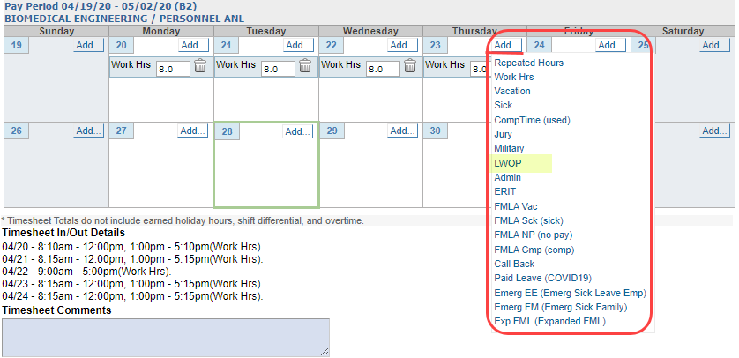

Figure 2: Sample Timesheet Calendar Showing LWOP for Monthly Employee

