**UCPath TRS DTA Quick Reference:  *DTA Adjustment – View/Edit Daily Breakdown***



In UCPath TRS the DTA has the ability to modify earn codes and hours submitted on a timesheet, in order to ensure the employee is properly paid. The **View/Edit Daily Breakdown** functionality is used to make these type of adjustments. This functionality is available, through the **Review/Submit Payroll** tab, under the Action column located on the following sub tabs:

View Current Monthly

View current Bi-Weekly

View Manual Transactions

*Only the DTA has access to this functionality to use sparingly, and for urgent situations. This feature can be used when an employee is on ERIT, and holiday pay needs to be adjusted.*

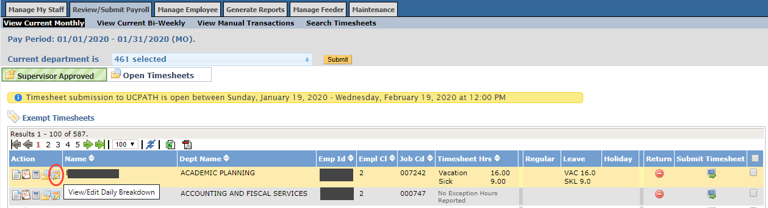

**How to View/Edit the Daily Breakdown for an Employee’s Timesheet:**

1. Log in TRS as DTA and navigate to the **Review/Submit Payroll** tab.
2. Select **View Current Monthly, View current Bi-Weekly,** or **View Manual Transactions** based on the type of employee.

***Note:***  *Any employee timesheet that TRS is unable to process via the View Current Monthly or View Current BiWeekly sections will automatically be routed to the* ***View Manual Transactions.***

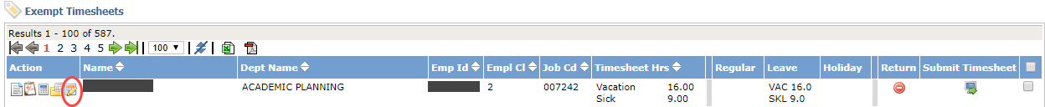

1. Click on the **View/Edit Daily Breakdown** icon, next to the employee timesheet. The “Timesheet Adjustment” window will be displayed.

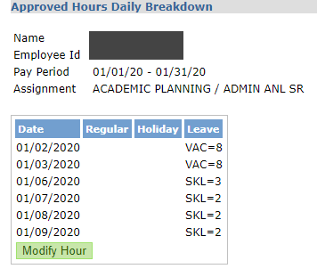

1. Click the **Modify Hour** button. The date, earn code and complete hours will be displayed.

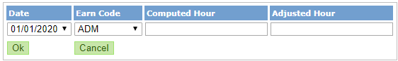

1. Select the **Date** to modify the earn code and/or hours for.
2. Select the applicable **Earn Code**.
3. Enter the number of hours that should be reported, under the **Adjusted Hour** Column.

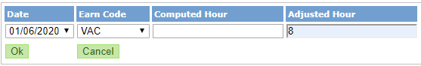

1. Click the **OK** button. The **Comment** box will be displayed.

The adjusted hours entered, will be displayed under the column associated with the selected earn code. A line will be drawn through the previous hours reported.

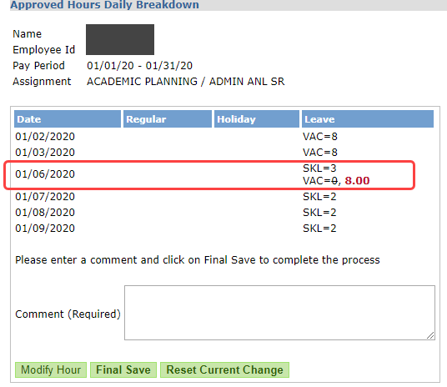

Example showing 8 hours of vacation added

1. Enter a comment to describe the reason for the change.

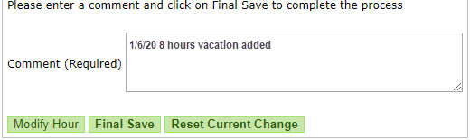

1. Click **Final Save** to keep the changes. After a brief delay, the timesheet will be modified, and the window closed. You will be returned to the timesheet roster. The changes made will be displayed, along with a flagged message “Adjusted by DTA”.

Other options:

* 1. Click **Reset Current Change** to disregard the changes
  2. Or, click **Modify Hour** to correct the hours entered.

*Before change*



***After change*** *– 8 hours added to vacation*



To **remove time** that should not be on the timesheet, repeat the above steps. **For steps 4 – 7**:

1. Select the date, and corresponding earn code to be removed. The current “Computed Hour” will be displayed.
2. **Enter 0 for the adjusted hour**.

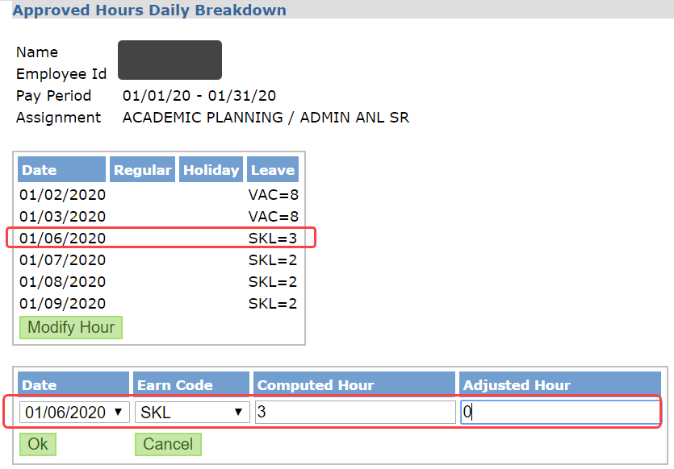

1. The adjusted hours will be displayed next to the date and earn code modified.

Enter **comments** regarding the change.

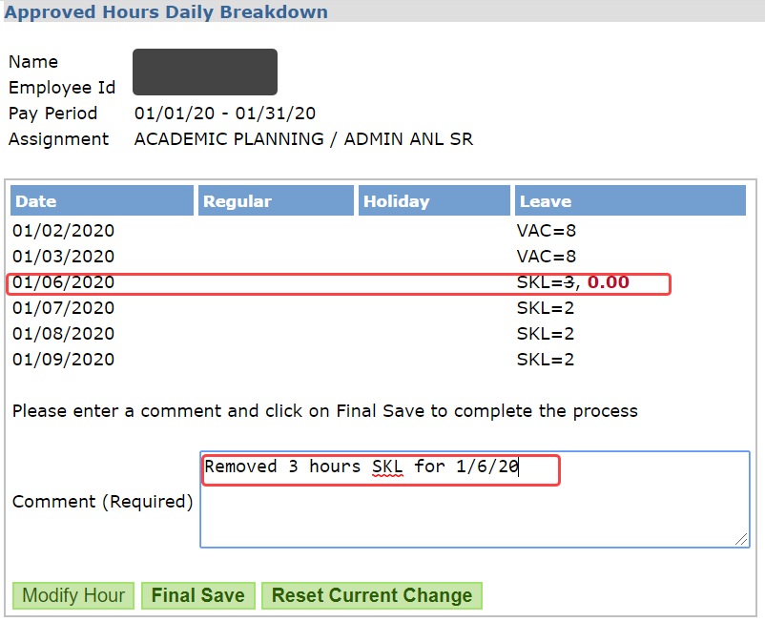

Example showing 3 hours of sick time removed

1. Click **Final Save** to keep the changes. After a brief delay, the timesheet will be modified, and the window closed. You will be returned to the timesheet roster. The changes made will be displayed, along with a flagged message “Adjusted by DTA”.

*Previous timesheet showed 9 hours, and now shows 3 hours less.*